Lab Session – Day 5

**Question:**

Use classicmodels. Find the total amount for each month of each year from payments table.

The output should look as shown in below image.

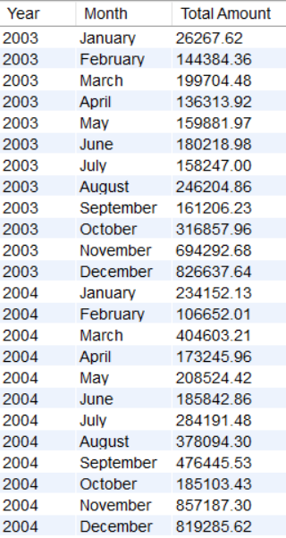

**Solution:**

Write the below query in MySQL workbench.

